Instructions for using the Roller

- It’s easier to start the roller outside of the garage. Put the gear into neutral and push out of the garage – it’s quite easy.
- To start make sure the roller is in neutral: the gear lever should be inbetween fast and slow and that the direction lever is inbetween forward and reverse.
- Put the throttle on full (fully down). Open engine bonnet, put the choke full on (push to left) and open the fuel line (black lever to right).
- Pull the cord and the engine should start, may take one or two goes. If it doesn’t start after 3/4 attempts close the choke otherwise the engine will flood. Try again 2 times and then re open choke etc.
- Once the engine has started you are good to go. Make sure the choke is closed.
- Only go forward – apparently it doesn’t like going backwards. Control the speed using the throttle and the speed control (fast and slow)
- When on the wicket always go slow ie. In slow gear and throttle fully up.
- To stop the roller place in neutral – see point 2.
- To turn off the engine push the engine off button.
Pre season rolling is always done across the width of the square, as the roller will only go forward you basically go in a big circle. Start by going down the edge (where the stumps go) as you reach the bottom of the square turn and then come back up the middle of the wickets, when you reach the top turn again and go back down where you started. Only this time roll over half of the original roll, this way you will gradually edge across the square and everything gets rolled twice.
The engine runs on unleaded petrol, should you need to get some more use one of the cans in the garage, keep the receipt and the club will refund you.

Good luck!

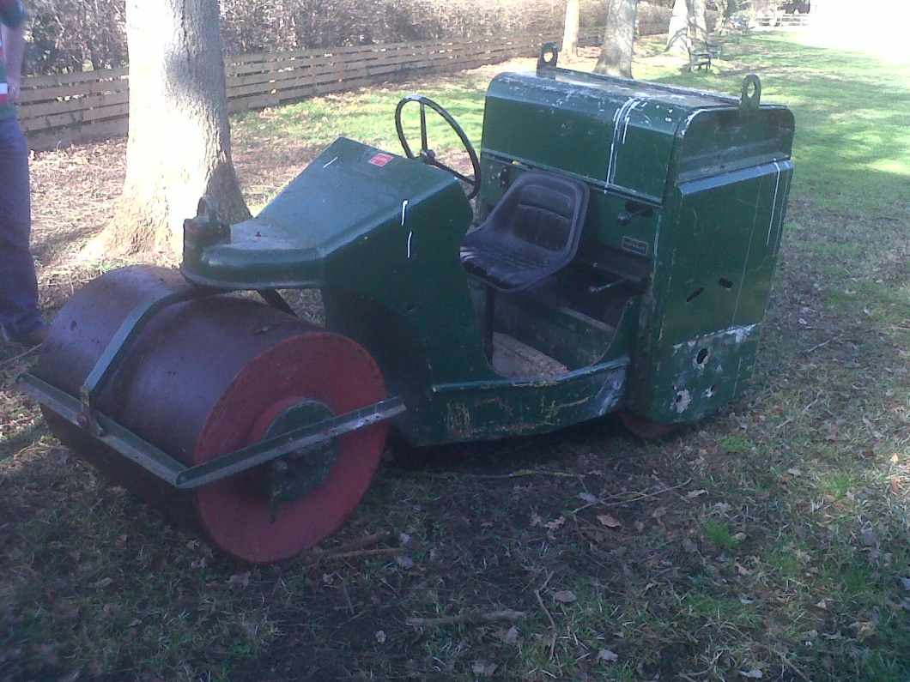
Throttle. Down is full throttle, fully up is low throttle. Always roll in low throttle.
This lever controls if you go forwards or backwards. Always go forwards. Somewhere in the middle is neutral.
This level controls speed. Slow or Fast. Somewhere in the middle is neutral. Always roll in slow gear.
Choke. Move to left to open fully. Right to close.
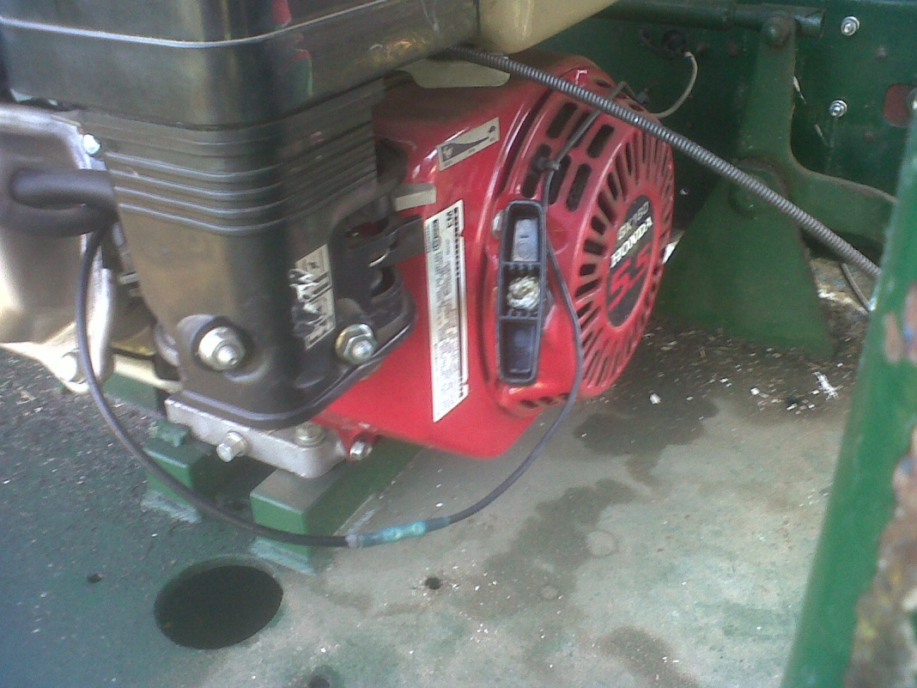
Cord – pull to start engine
Fuel lever. Move to right to open

